Tolerance Analysis

**Tolerance Stack-Up**

An important part of the Swiss Army Knife’s performance are for its tools to be able to be stacked against each other closely, but then be able to rotate out easily with little friction. Because the case ultimately restricts the number of moving components at either end of the shaft, the cumulative effect of the individual tolerances of the components has to accounted for to make sure they fit inside. This is known as the tolerance stack up. Moreover, GD&T was carried out using chain dimensioning at the stack-up, since each of the components on the shaft are separately manufactured (i.e. stack-up cannot be avoided by using baseline dimensioning). To ensure the stack-up does not exceed the allotted space in the case, the worst-case tolerance stack-up analysis was performed in SolidWorks. This process consists of 4 steps: (1) Tag the inside surface at the bottom of the case as “Measure From” (2) Tag the inside surface at the top of the case as “Measure To” (3) Select one-by-one the assembly sequence of components fitting in between (from top to bottom in the picture: the top rotating piece, the 1st utensil, the low friction bearing, the 2nd utensil) (4) Applying needed constraints. When this was analyzed, the TolAnalyst calculated the nominal, the minimum and maximum values of these part thicknesses, as reflected in the engineering drawings.

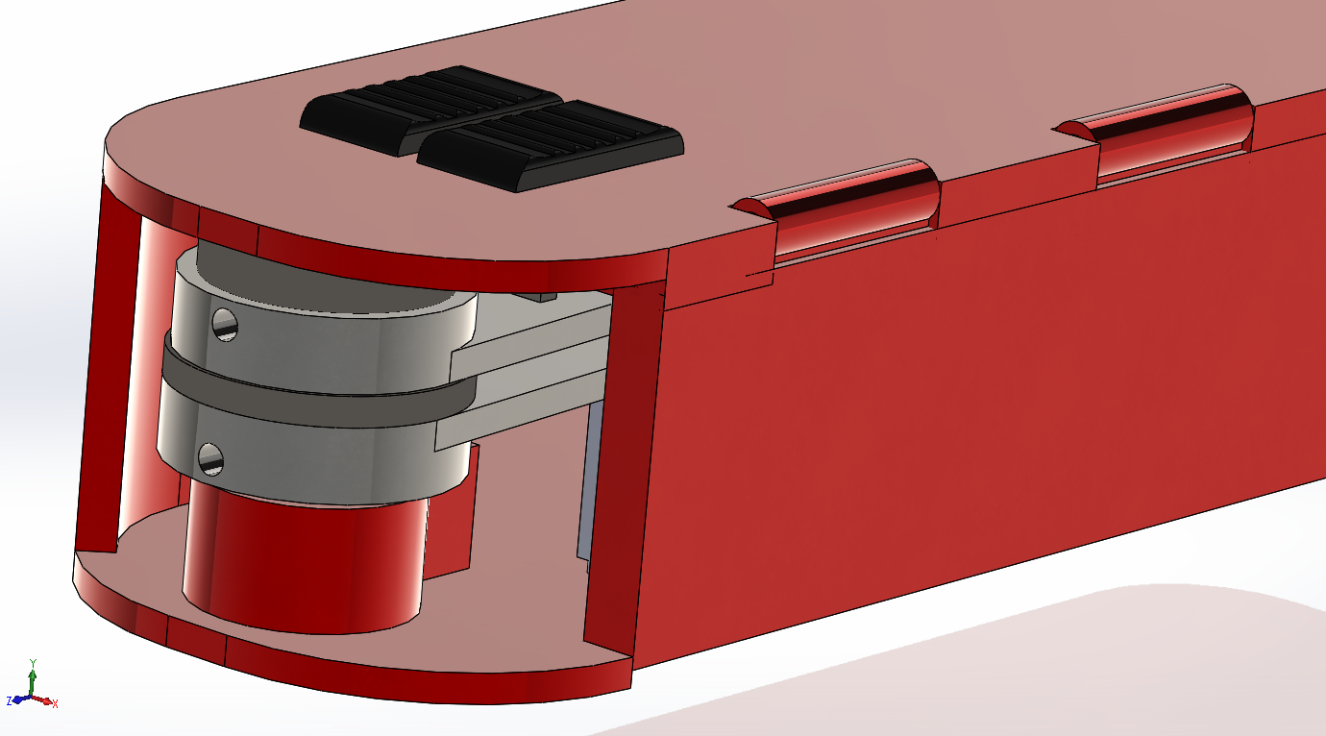

Fig: Stacking of Components at Shaft

**Engineering Fits**

In locations where two moving parts interface, an engineering fit is likely to occur. This is when one part “fits” into another such that their dimensions must be quality-controlled, or else the specific kind of interaction sought will vary greatly with the minor deviations in certain dimensions. For example, the tolerances for a shaft and hole for a “press fit” must be specified such that the largest clearance allotted by the tolerances of the two features still makes it a snug connection; on the contrary, a fit that needs clearance for maneuverability should still have it even in the worst-case production scenario within the stated tolerances. Descriptions of different fit types and their corresponding symbols from Shigley’s Mechanical Engineering Design are shown below:

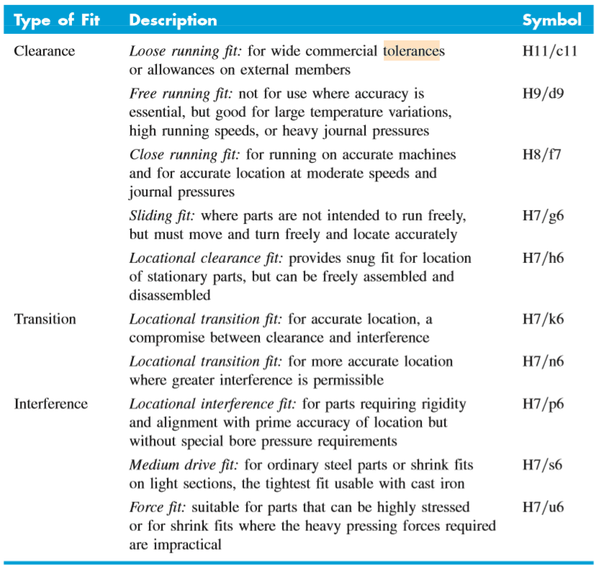

Fig: Description of Fits

Each interface that requires a certain kind of fit for functionality was listed below, and then ascribed a corresponding fit and symbol. The fit symbol is comprised first of a code for the “hole” component, or the cavity of the two parts, and a “shaft” component, or the moving component. These symbols are standardized by the ISO and can be found in the ISO handbook with corresponding schematics of what the fit may look like.

|  |  |  |
| --- | --- | --- |
| Interface | Fit | Symbol |
| Case Top (hinge), Door | Transition fit | H7 k6 |
| Door, Lock Casing | Clearance fit / loose running | H11 c11 |
| Lock Casing, Lock | Clearance fit / close running | H8 f7 |
| Lock Casing, Case Bottom | Interference / press fit | H7 p6 |
| Case Bottom (shaft), Utensil | Clearance fit / sliding | H7 g6 |
| Shaft, Thrust Bearing | Transition / similar fit | H7 k6 |
| Case Top, Case Bottom | Interference / press fit | H7 p6 |
| Case Top, Tool Release Linkage | Clearance fit / loose running | H11 c11 |
| Tool Release Linkage (pin), Utensil (pin hole) | Clearance fit / close running | H8 f7 |
| Tool Release Linkage, Tool Release Tab Top | Interference / driving fit | H7 s6 |
| Vertical Shaft Stack (Top Rotation Piece, Utensils, Thrust Bearing, Case) | Clearance fit / sliding | H7 g6 |
| Assembly 1 Case, Assembly 2 Case | Clearance fit / close running | H8 f7 |
| Torsion Spring, Utensil (hole for spring leg) | Transition / similar fit | H7 k6 |
| Torsion Spring, Case or Top Rotation Piece | Transition / similar fit | H7 k6 |
| Tool Release Spring, Case and Tool Release Linkage | Interference / press fit | H7 p6 |
| Lock Spring, Lock and Lock Casing | Interference / press fit | H7 p6 |

Table: Fit Classifications

The chart below is published in the ISO handbook. It matches fit symbols for each the hole and shaft component with specific tolerances based on their ascribed fit. The tolerances are not symmetric like is often seen in machining, since the upper and lower bounds of a tolerance may have to deviate from the nominal dimension differently to ensure the fit remains right. For each component in the table above, a tolerance was determined via this system, and is reflected in the drawings by their specific fit symbols. In cases where SolidWorks did not have a selection for the specific fit symbol sought, the closest fit type symbol was used. Note that the chart is in metric units, and that a conversion factor was used when consulting it with the english-unit engineering drawings.

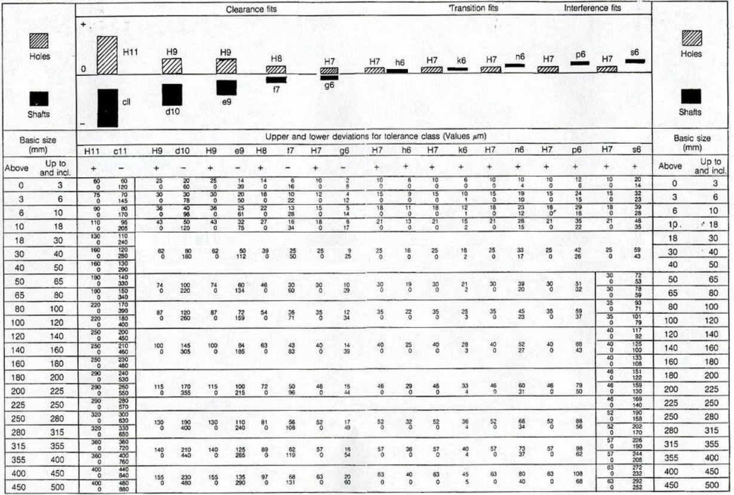

Chart: ISO Fits & Corresponding Tolerances

**Remaining Dimensions**

Remaining dimensions that do not have tolerance stack-up or engineering fit implications were assigned using tolerances published by the ISO standard tolerance grade chart. The smaller the IT grade number, the greater degree of precision is needed for the application. These dimensions were toleranced using IT16, which is described as for “”large manufacturing uses” which applies to a commercial Swiss Army Knife. The tolerances were inserted using the symmetry standard (same upper and lower limits). Note that the chart is in metric units, and that a conversion factor was used when consulting it with the english-unit engineering drawings.

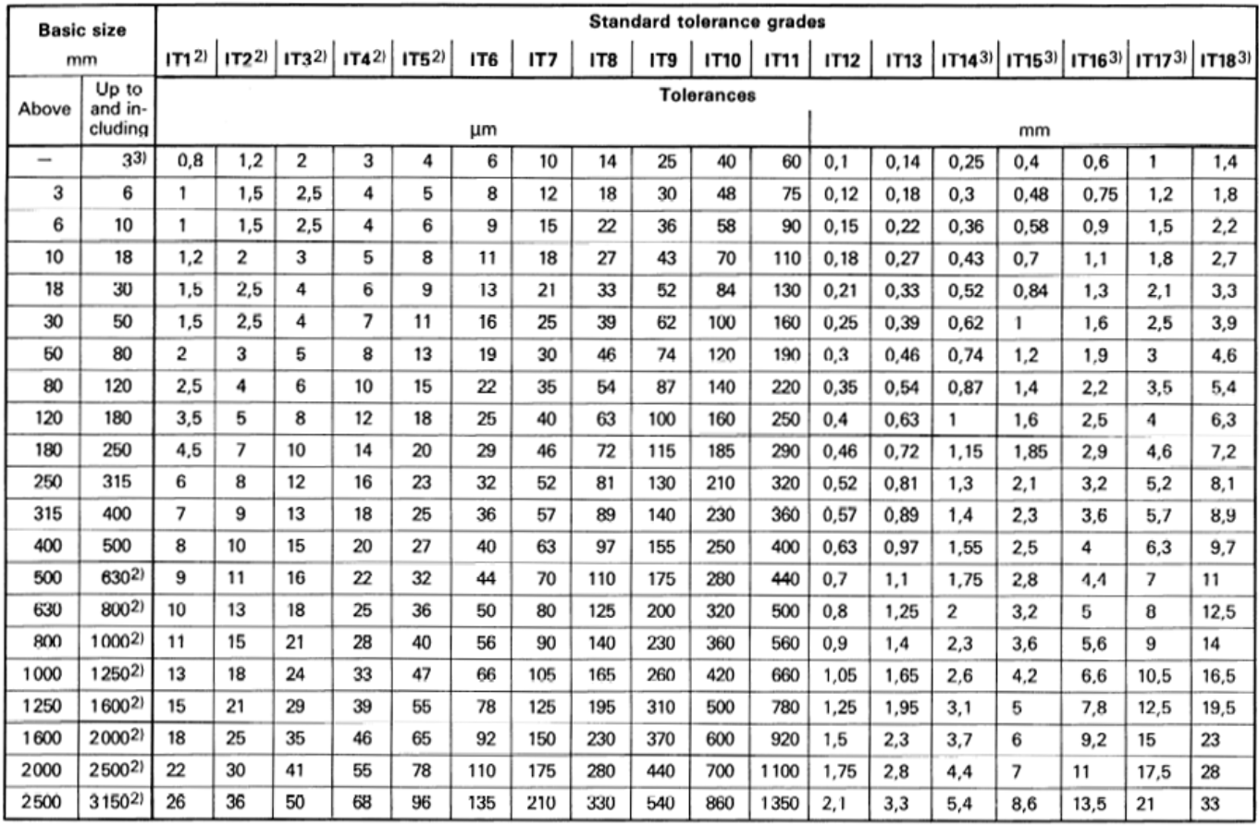

Chart: ISO Standard Tolerance Grades